Once completed this template is to be submitted in Word format (as an attachment) via the GRDC Grains Investment Portal.

Please do not embed this completed template within any GRDC forms.

The report should be limited to a maximum of ten (10) pages.

Annual Results Report Template

201X
Annual Results Report
[Insert project title]

Project code: | [insert GRDC project code]
Prepared by: | [insert researcher name]
[insert researcher email address]

[research organisation’s name]

[insert research administrator name]
[insert research administrator email address]

Date submitted to GRDC: | [day, month and year]

REPORT SENSITIVITY
Does the report have any of the following sensitivities?
Intended for journal publication YES/NO
Results are incomplete YES/NO
Commercial/IP concerns YES/NO
Embargo date YES/NO If Yes, Date: DD/MM/YYYY

KEY MESSAGES

SUMMARY
Results at a glance

BACKGROUND
Why do the work? Why was the trial done? What is the issue that led to the project, impetus for the work, or previous work that has led to this project?

OBJECTIVES
What are the objectives of the trial/experiment? What is intended to be achieved in carrying out the trial/experiment?

METHODS
How was the trial/experiment conducted? Avoid overly technical language; yet describe the way the project has approached the task.

LOCATION
NOTE: Where field trials have been conducted please include location details: Latitude and Longitude, or nearest town, using the table below (please add additional rows as required):
 | Latitude (decimal degrees) | Longitude (decimal degrees)
Trial Site #1
Nearest Town
Trial Site #2
Nearest Town

If the research results are applicable to a specific GRDC region/s (e.g. North/South/West) or GRDC Agro-Ecological Zone/s please indicate which in the table below:
Research | Benefiting GRDC Region  (can select up to three regions) | Benefiting GRDC Agro-Ecological Zone (see link: http://www.grdc.com.au/About-Us/GRDC-Agroecological-Zones ) for guidance about AE-Zone locations
Experiment Title | Choose an item.  Choose an item.  Choose an item. | ☐ Qld Central  ☐ NSW NE/Qld SE  ☐ NSW Vic Slopes  ☐ Tas Grain  ☐ SA Midnorth-Lower Yorke Eyre  ☐ WA Northern  ☐ WA Eastern  ☐ WA Mallee | ☐ NSW Central  ☐ NSW NW/Qld SW  ☐ Vic High Rainfall  ☐ SA Vic Mallee  ☐ SA Vic Bordertown-Wimmera  ☐ WA Central  ☐ WA Sandplain

RESULTS
What happened? Description of the results from the work so far, can include graphs / photos; some interpretation of what these mean in terms of farm practice or modified approaches to the underlying issue when interpreted for on-farm use.

CONCLUSIONS
Summary of findings, implications and future activities.

SOCIAL MEDIA POSTING
DISCLAIMER This report has been prepared in good faith on the basis of information available at the date of writing without any independent verification. The Grains Research and Development Corporation does not guarantee or warrant the accuracy, reliability, completeness of currency of the information in this report nor its usefulness in achieving any purpose. Readers are responsible for assessing the relevance and accuracy of the content of this report. The Grains Research and Development Corporation will not be liable for any loss, damage, cost or expense incurred or arising by reason of any person using or relying on the information in this report. Products may be identified by proprietary or trade names to help readers identify particular types of products but this is not, and is not intended to be, an endorsement or recommendation of any product or manufacturer referred to. Other products may perform as well or better than those specifically referred to.
GRDC uses social media to showcase research investments and disseminate timely, relevant and practical information to key stakeholders in the grains industry. Our audiences are predominantly growers and agricultural advisers.
SOCIAL MEDIA ACCOUNTS:
Facebook: https://www.facebook.com/theGRDC
Twitter: https://twitter.com/theGRDC
YouTube: http://www.youtube.com/user/theGRDC
LinkedIn: http://www.linkedin.com/company/thegrdc

Is there any reason why this report cannot be communicated on social media? (Insert info here)

If no, please provide the following:
- Who is the target audience for this content? (e.g., growers, adviser, researchers, policy makers, etc.)
  - (Insert info here)

- At what time of year is this content most relevant to the target audience?
  - (Insert info here)

- On which of GRDC’s social media accounts would you like this content posted? Please provide text (2-3 sentences for Facebook and LinkedIn and 140 characters for Twitter), images, graphs, or charts that support the content. Where applicable, please include any relevant Twitter handles (usernames) for project staff.
  - (Insert info here)

PROJECT SOCIAL MEDIA ACCOUNTS
Facebook: Twitter:
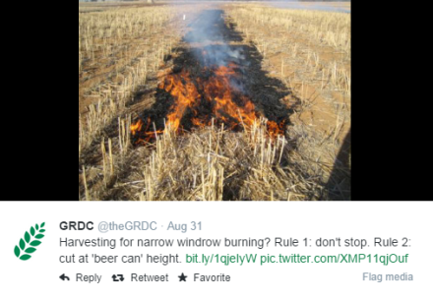
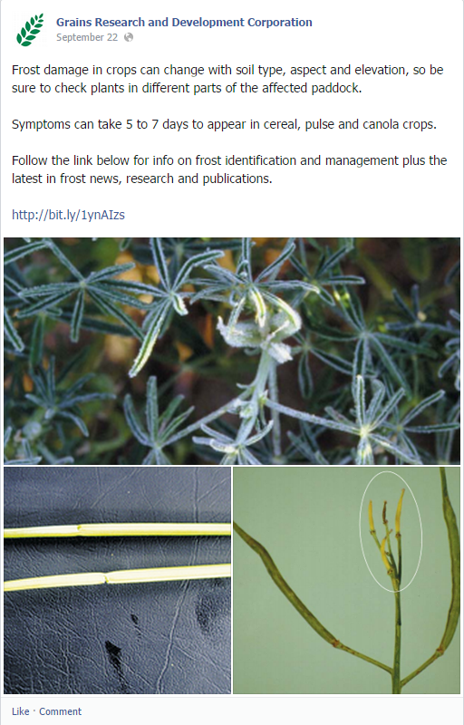

Contact the social media team at socialmedia@grdc.com.au with any questions.
Please note that publication of content to GRDC social media accounts is at the discretion of GRDC’s social media team.

REFERENCES & USEFUL LINKS
List of key publication references and web links relevant to the project and for further exploration of the topic.

