Once completed this template is to be submitted as an attachment against the contract Milestone Report in the Grains Investment Portal

Reports will only be evaluated by the GRDC if they are submitted via the Grains Investment Portal. If you have difficulty, please email the Primary Contact listed for the relevant contract.

Include any sensitivities in the report

The report should be limited to a maximum of ten (10) pages.

All guidance text (like this) should be deleted prior to submission.

Study Tour Report
Study Tour Report
[Insert contract title]

Contract code: | [insert GRDC contract code]
Prepared by: | [insert name]

REPORT SENSITIVITY
Does the report have any of the following sensitivities?
Intended for journal publication YES/NO
Commercial/IP concerns YES/NO

DISCLAIMER:
Any recommendations, suggestions or opinions contained in this publication do not necessarily represent the policy or views of the Grains Research and Development Corporation (GRDC). No person should act on the basis of the contents of this publication without first obtaining specific, independent professional advice.
The Grains Research and Development Corporation may identify products by proprietary or trade names to help readers identify particular types of products. We do not endorse or recommend the products of any manufacturer referred to. Other products may perform as well as or better than those specifically referred to. The GRDC will not be liable for any loss, damage, cost or expense incurred or arising by reason of any person using or relying on the information in this publication.

Caution: Research on Unregistered Pesticide Use
Any research with unregistered pesticides of unregistered products reported in this publication does not constitute a recommendation for that particular use by the authors or the authors’ organisations.
All pesticide applications must accord with the currently registered label for that particular pesticide, crop, pest and region.
Copyright © All material published in this publication is copyright protected and may not be reproduced in any form without written permission from the GRDC.

Introduction
This may be used as a web summary. As such it is recommended that key words or phrases be included when writing it to assist search engines in finding your material.
The introductory paragraph lets the reader know what the topic/subject of the report is and explains the purpose of the study tour.
This should be a fully self-contained description of your report. It should summarise the thrust of the study tour – why it was relevant. Please write in clear language and avoid jargon.
Maximum of 10 lines/200 words.

Executive Summary
This section enables readers to understand the original learning objective of the study tour, and subsequent learnings and recommendations. For example, briefly:
- Why the tour was undertaken/research question it sought to answer
- How the tour proposed to answer its research question i.e. reasoning behind the proposed itinerary, sites/events and people to be visited
- What was ultimately learned
- How growers or the broader Australian grains industry can benefit from the learnings
The sections below can be used to expand on the above, so be clear and succinct in this Executive Summary section.
Maximum 500 words.
You may use excerpts from your original application where appropriate.

Background
The Background should discuss the origins of the study tour, including any research that is relevant to the topic.

Objectives
This section will outline the objective/s of the study tour and whether it was achieved
- Why the tour was undertaken/research question it sought to answer
- Was the objective/s achieved? If so, outline how.

Study Tour details
How the tour proposed to answer its research question i.e. reasoning behind the proposed itinerary, sites/events and people to be visited
Tour makeup
For example: growers, advisers, researchers, organising staff (if not grower etc)
Role | Number
Grower

Locations
 | Name | Purpose (briefly) | Nearest Town
Site visit #1
Site visit #2

Photos/images
All photos/images used in reports should be supplied in high resolution if possible (above 3MB in file size). Separate files may be required for larger MB pictures.

The following information should be included with photographs:
- The name and contact details of the photographer
- The name and contact details of people appearing in the photograph
- The date on which the photograph was taken
- A detailed description of the image and what it depicts.

Permission to have their photograph taken and used for this purpose should be obtained from any person appearing photographs provided to the GRDC.

Findings
Discussion of the study tour’s findings and their implications for growers and industry, including any economic implications. Use graphs / photos and statistical analysis where appropriate.

Conclusion and recommendation(s)
The conclusion does not introduce new topics or ideas, but does consider broader implications of the learning objective, discuss possibilities for future research.

National Grower Network (NGN)
Is there an opportunity to engage with the NGN forums or consider local demonstration and/or extension (D&E) or local validation trials?

Communication
GRDC values the dissemination of study tour findings beyond the tour group, as such please include in this section details of communication outputs produced such as key social media posts, articles, newsletters, blogs, videos and presentations
Samples:
Facebook: Twitter:
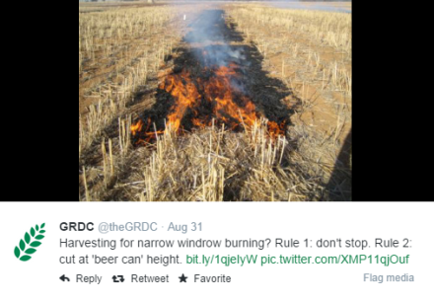
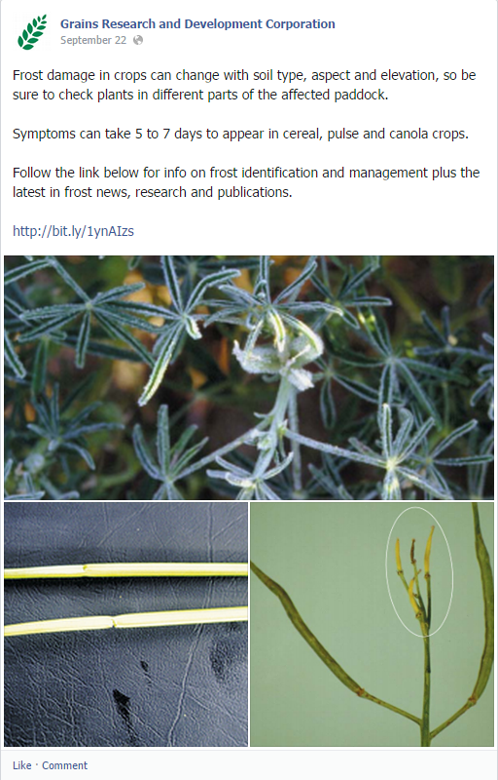

Contacts:
With their permission, contact information for participants of the study tour may be provided here.
References
List details here of any articles, journals, and/or other publications referred to in the report.

