Spraying for RLEM could become a thing of the past
Svetlana Micic and Alan Lord, Department of Primary Industries and Regional Development.

Keywords redlegged earth mites, resistance, synthetic pyrethroids, organophosphates
GRDC Project Code: UM00057
Key messages
- Redlegged earth mites (RLEM) that have developed resistance to organophosphates and synthetic pyrethroids are becoming more common in broadacre farming systems in Western Australia.
- As a consequence, the industry will need to look at alternatives to spraying insecticides to control RLEM.
Introduction
At the 2015 Crop Updates we reported that we had identified RLEM with combined omethoate (Group 1B) and synthetic pyrethroid (Group 2A) resistance and indicated that current insecticides might have limited control in the future.
The following year, we reported finding RLEM at a single location that were resistant to the organophosphate chlorpyrifos. However, further testing revealed these mites were not resistant to either omethoate, synthetic pyrethroids or methidathion.
From 2017 to 2019, the Department of Primary Industries and Regional Development (DPIRD) carried out resistance testing in Western Australia as part of a Grains Research and Development Corporation (GRDC) investment being led by the University of Melbourne, in collaboration with ‘cesar’ and the Commonwealth Scientific and Industrial Research Organisation (CSIRO). Insecticides used in the study were selected by the national team and used for resistance testing throughout broadacre growing regions of Australia. The findings for 2019 are presented in this paper.

Aim
To determine the extent of RLEM insecticide resistance in the Western Australian wheatbelt.

Method

Mite collection
Agronomists were recruited to participate in a survey to determine the extent of RLEM resistance. Paddocks suspected of having a chemical failure or farms with high levels of pesticide usage were selected.
At least 2000 RLEMs were collected using a suction sampler and placed into airtight containers with moistened paper towel and plant material and then refrigerated.
Method for bioassays
The inside of 5 mL vials were coated with either:
- Bifenthrin at 0.1 g.a.i./L (equivalent to field rate) (Group 2A)
- Omethoate at 0.00087 g.a.i./L (equivalent to LD₉₀) (Group 1B)
- Omethoate at 0.0058 g.a.i./L (approximately equivalent to 1/5 of label rate) (Group 1B)
- Malathion at 0.015 g.a.i/L (equivalent to LD₉₀) (Group 1B)
- Malathion at 0.5 g.a.i/L (approximately equivalent to unregistered label rate) (Group 1B)
- Control (water)

Mites from a known susceptible source were used to compare results with the survey populations.
Treatments for RLEM surviving omethoate and/or malathion bioassays
The inside of 5 mL vials were coated with either:

- Omethoate at 0.29, 0.029, 0.0029, 0.00029, 0.000029, 0.0000029 g.a.i./L
- Chlorpyrifos at 0.7, 0.07, 0.007, 0.0003, 0.0007, 0.00007, 0.000007 g.a.i./L
- Control (water)

Mites from a known susceptible source were used to compare results with the test populations.
Testing for resistance
Vials were coated with the required insecticide concentration then left upside down at room temperature until the inner surface was completely dry. Once dry, a vetch leaf was placed at the bottom of each vial.
Eight healthy RLEM from each collection site were placed on top of the vetch leaf in each vial. Each treatment had six replicates.
After 24 hours, mites were counted as either dead or alive.

Results and discussion
Mites were collected from the high- to medium-rainfall areas of WA, from Gingin to Esperance and as far west as Cowaramup. Mites were bio-assayed from a total of 73 sites with more than half of these sites (42 sites) having mites surviving exposure to either omethoate at 0.0058 g.ai/L and/or malathion at 0.5 g.a.i/L and/or bifenthrin at 0.1 g.a.i/L.
Of the 42 sites with survivors, less than half (43%) had RLEM surviving exposure to a single insecticide.
- Only about 30% (14 sites) had RLEM surviving exposure to bifenthrin alone. In previous trials, mites surviving rates of bifenthrin were resistant to all synthetic pyrethroid insecticides (Group 2A) but were still susceptible to organophosphates.
- About 10% of sites had RLEM that survived omethoate (three sites) or malathion (one site) indicating that synthetic pyrethroids are still effective at controlling mites at these sites.

About 60% of sites with RLEM surviving the bioassays had RLEM that survived exposure to more than one insecticide:
- Of these 24% (10 sites) had RLEM that survived exposure to omethoate and malathion indicating that RLEM are becoming more tolerant of more than one insecticide in the Group 2B range. Even so, at these sites synthetic pyrethroids will still have efficacy.
- Cross resistance to synthetic pyrethroids and omethoate was found at 5% of sites (two sites) but at these sites, malathion still had efficacy.
- Of concern, is that about 30% (12 sites) had RLEM that survived all three insecticides. At these sites synthetic pyrethroids have little efficacy in controlling RLEM. Also, the organophosphates malathion and omethoate as well as other insecticides in the organophosphate group are unlikely to provide ongoing control for RLEM.

Mites from 13 sites that survived exposure to malathion (0.50058 g.a.i/L) and/or omethoate (0.0058 g.a.i/L), were re-tested with more rates of omethoate and chlorpyrifos. Mites from the 13 sites all survived at higher rates of exposure to omethoate and chlorpyrifos than the control population.
Results from only Site 1 and Site 2 are presented here. At these sites, growers reported RLEM surviving applications of registered rates of organophosphates and synthetic pyrethroids. Compared to the control it took 100 times more omethoate at Site 1 and 10 times more omethoate at Site 2 to kill RLEM (Figure 1). For chlorpyrifos, there were survivors at both sites even at 10 000 times the rate that killed RLEM in the susceptible population (Figure 2).

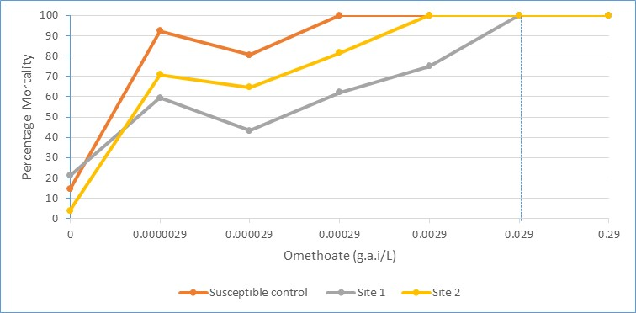
Figure 1. Mortality of redlegged earth mites from three sites exposed to omethoate at various rates. Vertical dotted line indicates field rate.

Figure 2. Mortality of redlegged earth mites from three sites exposed to chlorpyrifos at various rates. Vertical dotted line indicates field rate.

Conclusion
Organophosphates such as omethoate (Group 1B) and synthetic pyrethroids such as bifenthrin (Group 2A) cannot be relied on effectively control RLEM in the long-term. Alternative control measures need to be considered such as:
- Use of crop rotations that fit with the farming system to supress RLEM. For example, growing crops susceptible to RLEM damage such as canola after crops that do not support large RLEM populations such as cereals.
- Heavy grazing pasture paddocks to a residual of 1400 kg DM/ha through spring in the year before sowing crops susceptible to RLEM such as canola.
- Weed control to reduce habitat for mites. A weed-free crop will have few mites and over-summering eggs to carry through to the following season.
- The use of insecticidal seed dressings
- The use of alternative insecticides. If sprays need to be applied for the control of other pests (e.g. aphids) consider using insecticides not in the synthetic pyrethroid or organophosphate groups.

For further information refer to the Resistance Management Strategy for RLEM at: https://grdc.com.au/FS-RLEM-Resistance-strategy

Acknowledgments
The research undertaken as part of this project is made possible by the significant contributions of growers and agronomists. The authors would like to thank them for their continued support.

Contact details
Svetlana Micic
Department of Primary Industries and Regional Development
444 Albany Hwy, Albany, WA, 6330
Ph: 9892 8591
Email: svetlana.micic@dpird.wa.gov.au

