Can double break-crop rotations be effective and profitable across the wheatbelt?

Nathan Craig, West Midlands Group, Veronika Crouch, Corrigin Farm Improvement Group

Key words Double break, rotations, legumes, canola, wheat
GRDC Project Code Number: WMG00003-A

Key messages
- Double break-crop rotations can provide effective weed and disease control if well managed.
- The profitability of double break-crop rotations was lower compared to growing continuous wheat in this study, however, the yield of all break-crops was impacted by severe frosts in 2016 and dry growing season conditions in 2017.

Introduction
In Western Australia, break-crop options are currently limited and there is a high proportion of wheat and barley grown across the WA grain growing region (Harries et al 2015). Cereal crops account for 60-70% of paddocks sown in any one year, with the remaining area sown to a range of crop and pasture types including canola, lupin, clover, volunteer pasture, or left as fallow (Harries et al 2015). The application of these break-crops is dependent on the presence and severity of biological, chemical and physical constraints in each paddock that can impact on the successful growth of the break-crop. The use of a single break-crop is an effective tool in managing weed and disease constraints that affect the long-term productivity of cereal based rotations (Kirkegaard et al 2008). However, a change in herbicide resistance status of many common weeds and population dynamics of soilborne pathogens means that a single break-crop is now having a limited effect in reducing these common biological constraints (Swan et al 2015). The use of two break-crops in a row as a double break-crop sequence has been successfully used to increase the grain yield of successive wheat crops in south-eastern Australia in situations where there are high levels of biological constraints (Moodie et al 2017). Considering the high percentage of cereal crops grown in WA, there is a need to evaluate the use of double break-crop sequences to reduce the impact of biological constraints on wheat grain yield and profitability. In particular, the eastern wheatbelt region has very limited break-crop options, and there is a need to investigate the better use of tools such as fallow periods to improve break-crop outcomes.

Method
A replicated field site was established 12km north of Merredin in the eastern wheatbelt of WA on a paddock that had a high background population of annual ryegrass (Lolium rigidum). The site had been previously cropped to wheat in 2015 and had a soil pH_{(CaCl)} of 4.8 in the 0-10cm and 4.6 in the 10-20cm soil depth. Twelve double break rotations were established in 2016 in a randomised block design experiment with four replicates (Table 1). This site was sown using a knifepoint seeder with press wheels on 24.7cm spacing and mechanically harvested with a plot harvester.
Table 1. Double break-crop sequences evaluated at the Merredin trial site for the 2016-18 period.

Treatment | 2016 Crop | 2017 Crop | 2018 Crop
1 | Vetch | Canola | Wheat
2 | Lupin | Canola | Wheat
3 | Balansa | Canola | Wheat
4 | Fallow | Fallow | Wheat
5 | Fallow | Chickpea | Wheat
6 | Fallow | Lentil | Wheat
7 | Fallow | Canola | Wheat
8 | Sub-clover | Canola | Wheat
9 | Fallow | Balansa | Wheat
10 | Fallow | Field pea | Wheat
11 | Fallow | Oats | Wheat
12 | Wheat | Wheat | Wheat

In addition, four demonstration sites were established in 2017 near Bencubbin, Corrigin, Miling and Calingiri. These sites were established in paddocks with a history of root diseases or weed populations that a single break-crop could not address, and which were sown to a break-crop, pasture or fallow in 2016. In 2017, plots of up to two hectares in size were established using grower equipment for a range of break-crop options that the grower had identified to integrate into their farming system. The remaining area of the paddock was sown to either wheat or canola depending on the grower’s paddock plan.
In the 2017 and 2018 season, measurements were taken on the demonstration plots to gauge the establishment, growth and grain yield of each break-crop species. Biomass production was measured using 0.1m² quadrat cuts (three replicates) at the start of flowering for legume crops in 2017; and at the end of tillering (GS.30) and anthesis (GS.65) for wheat in 2018. Final harvest yield was measured at maturity by cutting the number of plants along either side of a 50cm ruler (equivalent to one metre of crop row) in three replicate locations for each break-crop. Each sample was threshed and converted to kg/ha using a factor of 40 for the 24.7cm spacing and 33 for the 30cm row spacing. Ryegrass panicle counts were done at the flowering stage of wheat by counting the number of panicles in a 33x33cm quadrat (equivalent to 0.1m², with three replicates).
The collection of crop input data allowed for the gross margin return to be calculated for each break-crop sequence in each season. Gross Margin was calculated as the income received from the yield and value of grain per hectare based on current commodity prices, minus the variable costs associated with the growing of the crop (including machinery at contract rates). The Net Margin was calculated by further subtracting an allocation of $150/ha per year for overheads. The Cumulative Gross Margin was calculated as the sum of the Gross Margin for each year and adjusted to net present day value (NPV) by applying a discount of 5%. The Cumulative Net Margin is the sum of the Net Margin for each year adjusted to present day value by applying a discount of 5%.

Results
Growing season rainfall was well below average at the Merredin site in 2017 and closer to average for the 2016 and 2018 seasons (Table 2). Above average summer rainfall occurred in 2016 and 2017, and severe frosts were recorded in 2016 that affected all sites (data not presented). Break-crop growth and grain yield in this study were reduced by frost in 2016 and by dry growing-season conditions in 2017. Wheat growth and yield were not affected by severe seasonal conditions in 2018. This variability in seasonal conditions was representative of all sites in this study.
Table 2. Rainfall (mm) for the Merredin site for the period 2016-18 compared to the long-term mean (1903-2018). Growing season rainfall (GSR) is calculated from April to October in each year.

 | J | F | M | A | M | J | J | A | S | O | N | D | Tot | GSR
2016 | 41 | 12 | 76 | 55 | 42 | 43 | 39 | 42 | 21 | 11 | 2 | 22 | 407 | 253
2017 | 32 | 53 | 21 | 5 | 28 | 5 | 36 | 48 | 48 | 26 | 11 | 6 | 318 | 195
2018 | 23 | 11 | 9 | 1 | 11 | 39 | 52 | 62 | 3 | 44 | 18 | 24 | 297 | 212
Mean | 15 | 15 | 21 | 23 | 40 | 49 | 50 | 39 | 26 | 19 | 15 | 14 | 325 | 245

Grain yield and weed/disease levels
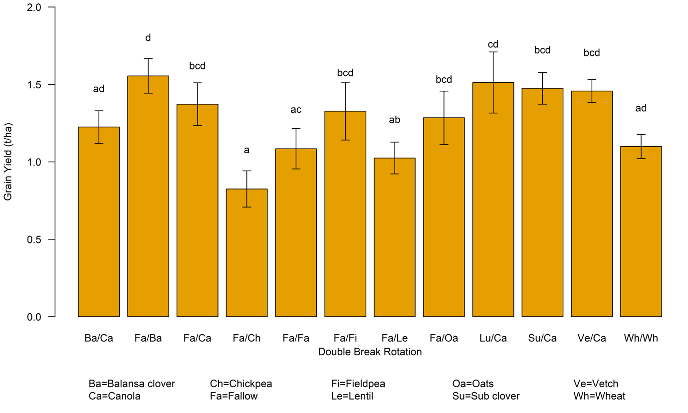
Figure 1. Grain yield of wheat grown after a series of double break-crop rotations at the Merredin site in 2018 (mechanical harvest). Error bars denote standard error of treatment mean; lower case letters denote a significant difference (P<0.05).
The grain yield of wheat in 2018 tended to be higher where fallow, canola, or balansa clover were used as one of the break-crops in the crop sequence (Figure 1). In contrast, grain yield was lowest following fallow/chickpea, fallow/lentil, and fallow/fallow. Grain protein was influenced by break-crop rotation, with the lowest protein occurring following fallow/oats and fallow/chickpea (data not presented). In general, grain protein was improved following treatments that had canola or balansa clover as the second break-crop preceding wheat in 2018.
The number of ryegrass panicles was significantly higher for fallow/chickpea and fallow/lentil compared to all other treatments (which had similar numbers of ryegrass panicles) (Figure 2). The population of annual ryegrass was not reduced to a level that would allow for a long phase of cereals to be grown. Using a benchmark of 50 heads/m² as the upper threshold for implementing a break-crop phase in this environment (D McGuinness, pers.comm), all break-crop rotations evaluated were just below this threshold after one year of wheat production. The use of fallow and canola appear to be effective break-crop options, however, the fallow treatment at the Merredin site was a spray-topped pasture and this is likely to have achieved lower ryegrass control compared to a clean chemical fallow. The results from the Merredin site also highlight the need to select the correct break-crops for paddock conditions, as high ryegrass numbers and low soil pH made this site not well suited to growing poorly competitive and susceptible species such as chickpea and lentil.

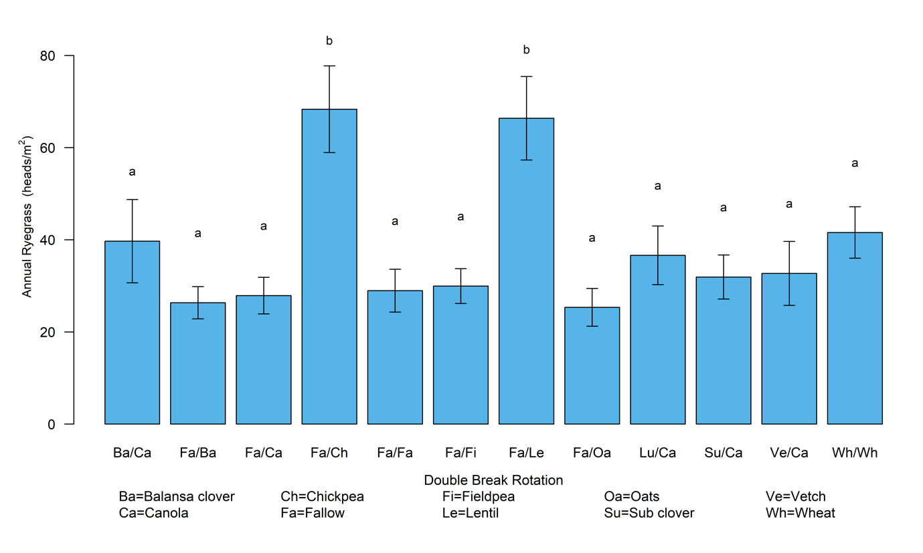
Figure 2. The number of ryegrass panicles (heads) present in each treatment measured in wheat during grain fill in 2018 following the double break rotations in 2016/17. Error bars denote standard error of treatment mean, lower case letters denote significant differences between treatments (P<0.05).
Hand harvested grain yield for the second break-crop at the demonstration sites in 2017 was highest for lupin and varied from 0.97t/ha to 1.42 t/ha, while chickpea, lentil and field pea yielded 0.67-1.1t/ha, 0.3-0.97t/ha, and 1.2t/ha respectively (Table 3). The use of a fallow was an effective way to increase soil moisture to benefit the growth of chickpea and lentil in what was considered a dry year. In contrast to the Merredin site, the fallow period was maintained as a clean chemical fallow which allowed for effective weed control, an increase in stored soil moisture and an accumulation of nutrients through mineralisation processes. The yield of wheat at the demonstration sites following legume break-crops tended to be higher than those of canola or wheat planted in the remaining paddock area. The driver of the increased wheat yield following legume breaks appeared to be the fixation of nitrogen rather than the reduction in root disease levels as changes in soil disease levels did not reflect differences in grain yield. Each legume crop had a different influence on the profile of soil diseases and this led to either a decrease or change in composition of soil diseases (Figure 3). In particular, the higher prevalence of P.neglectus due to the susceptibility of chickpea (and canola) was most pronounced and this is an issue that will need to be managed in the future as growers look to introduce a high-value legume species into their crop rotation to improve profitability. A thorough evaluation by growers of break-crop species will be important in the future to ensure effective control of paddock specific root diseases.
Table 3. Grain yield of wheat in 2018 at each demonstration site following various break-crops in 2017. nd = not determined. Demonstration site data only, no replication at each site. Grain yield determined by hand harvest cuts in each year.

Site | 2016 crop | 2017 crop | 2017 yield  (t/ha) | 2018 Wheat yield  (t/ha)
Bencubbin | Fallow | Canola | 0.6 | 2.1
 |  | Lentil | 0.6 | 2.8
 |  | Lupin | 1.42 | 2.6
 |  | Kabuli Chickpea | 0.6 | 2.8
 |  | Desi Chickpea | 1.1 | 3.4
Calingiri | Wheat | Lentil | 0.36 | 6.2
 |  | Lupin | 0.97 | 5.7
 |  | Canola | nd | 5.6
Corrigin | Fallow | Albus lupin | 0.8 | 3.9
 |  | Chickpea | 0.9 | 4.0
 |  | Field peas | 1.2 | 4.1
 |  | Lentil | 0.3 | 4.1
 |  | Wheat | 2.4 | 3.8
Miling | Pasture | Lupin | 0.97 | nd
 |  | Lentil | 0.82 | nd
 |  | Chickpea | 0.67 | nd

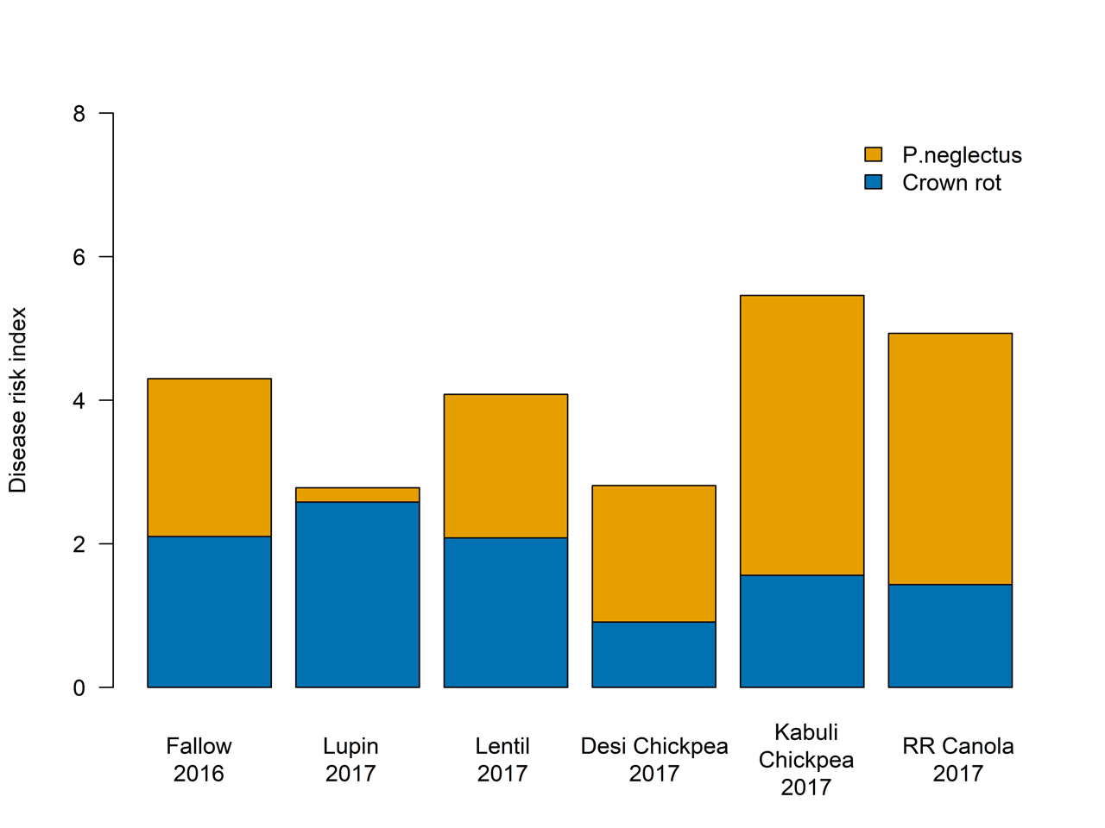
Figure 3. Soilborne disease levels at the Bencubbin site following fallow in 2016 and a range of legume break-crops grown in 2017. PredictaB sampling was conducted at the start of the 2017 and 2018 seasons following each respective crop. Roundup Ready canola (RR Canola) was grown in the paddock around the demo sites and is included as a comparison. Disease risk index: 0 = low, 8= high.
Rotation profitability
Double break-crop rotations were not as profitable as a continuous wheat sequence and in many cases for the eastern wheatbelt they generated a negative Net Margin over a three-year period (Table 4). The inclusion of high-value legumes such as chickpea and lentil as the second break-crop following fallow provides promise for improved profitability, but further evaluation is required to sufficiently de-risk this crop option for the eastern and central wheatbelt.
The Gross Margin of each crop was impacted by adverse seasonal conditions during the 2016 to 2018 period. There were several frost events in 2016 that reduced the grain yield of harvested crops, while in 2017 dry seasonal conditions reduced the growth, yield, and harvestability of many of the break-crops at all sites. This had a strong effect on the yield of each crop in each of the 2016 and 2017 seasons. Fallow in 2016 in many treatments resulted in a small Gross Margin loss, but a significant loss when machinery and overhead costs were included in the Net Profit (Table 4). Of the break-crops grown in 2016, lupins were the only crop to achieve a positive Gross Margin as there was severe frosting of the wheat. In 2017, the low yield of canola meant that the Gross Margin was roughly break even, while field pea, oats and wheat achieved positive Gross Margins due to better harvestability. Wheat grown across all sites in 2018 achieved a positive Gross Margin which varied from $90/ha following chickpea to $309/ha for wheat following balansa clover. The cumulative Gross Margin (expressed in present day value) for each crop sequence was positive for all crop sequences but varied from $25/ha for Fa/Ch/Wh to $532/ha for the highest break-crop rotation (Lu/Ca/Wh). Wheat monoculture achieved the highest cumulative Gross Margin of $826/ha while Fa/Oa/Wh was second highest at $694/ha. However, when comparing the Net Margin (in present day value) which includes machinery and overhead costs, all break-crop sequences returned a negative return over the three-year period.
Table 4. Gross Margin and Net Margin ($/ha) of double break-crop rotations at the Merredin site across the 2016 to 2018 seasons. Gross Margin is calculated as gross income minus variable costs, while Net Margin includes cost allocations for machinery use at contract rates and an overhead cost allowance of $150/ha. Net Present Value (NPV) gives the discounted value of the future gross margin in today’s value at the 5% rate. Fa=fallow, Ca=canola, Le=lentil, Ch=chickpea, Lu=lupin, Fi=field pea, Ba=balansa clover, Oa=oats, Su=sub clover, Ve=vetch, Wh=wheat.
 | 2016 |  | 2017 |  | 2018 |  | Cumulative
 | Gross Margin | Net Margin | Gross Margin | Net Margin | Gross Margin | Net Margin | Gross Margin | Net Margin
Crop sequence |  |  |  |  |  |  | NPV | NPV
Ve/Ca/Wh | -$20 | -$296 | $2 | -$274 | $282 | $6 | $226 | -$525
Lu/Ca/Wh | $287 | $11 | $2 | -$274 | $297 | $21 | $532 | -$220
Ba/Ca/Wh | -$78 | -$354 | $2 | -$274 | $213 | -$63 | $112 | -$640
Fa/Fa/Wh | -$14 | -$172 | -$18 | -$176 | $168 | -$108 | $116 | -$416
Fa/Ch/Wh | -$14 | -$172 | -$44 | -$320 | $90 | -$186 | $25 | -$614
Fa/Le/Wh | -$14 | -$172 | -$33 | -$309 | $153 | -$123 | $88 | -$551
Fa/Ca/Wh | -$14 | -$172 | $2 | -$274 | $255 | -$21 | $209 | -$430
Su/Ca/Wh | -$96 | -$372 | $2 | -$274 | $285 | $9 | $157 | -$595
Fa/Ba/Wh | -$14 | -$172 | -$101 | -$259 | $309 | $33 | $162 | -$370
Fa/Fi/Wh | -$24 | -$182 | $99 | -$177 | $243 | -$33 | $277 | -$362
Fa/Oa/Wh | -$36 | -$194 | $583 | $307 | $231 | -$45 | $694 | $55
Wh/Wh/Wh | $129 | -$147 | $609 | $333 | $174 | -$102 | $826 | $74

The gross margins for each crop sequence at the Bencubbin and Corrigin demonstration sites are presented in Table 5, where there was a negative gross margin for the fallow treatment in the first year. While conditions were dry in 2017, all break-crops at the Bencubbin site achieved a positive Gross Margin due to an effective fallow in 2016 providing excellent weed control and moisture conservation. At the Corrigin site in 2017, chickpea and lentil were the only break-crops to not achieve a positive Gross Margin as there were issues with weed control and the harvestability of these crops due to the dry season. It is important to note that the Bencubbin site was hand harvested while the Corrigin site was machine harvested by the grower and resulted in greater harvest seed loss. This difference in yield assessment method has greatly influenced the comparative Gross Margin at each site. The Gross Margin for wheat in 2018 at both sites ranged between $515/ha for Fa/Ca/Wh at Bencubbin to $1110/ha for Fa/Albus Lupin/Wh at Corrigin. The Net Margin was positive for all crop sequences except those with canola, lentil and Kabuli chickpea at Bencubbin.

Table 5. Gross Margin and Net Present Value (NPV) of double break-crop rotations at the Bencubbin (Eastern) and Corrigin (Central Wheatbelt) demonstration sites across the 2016 to 2018 seasons. Gross Margin is calculated as gross income minus variable costs, while Net Margin includes cost allocations for machinery use at contract rates and an overhead cost allowance of $150/ha. NPV gives the discounted value of the future gross margin in today’s value at the 5% rate. Fa=fallow, Ca=canola, Le=lentil, Ch=chickpea, Lu=lupin, Fi=field pea, Wh=wheat.
 | 2016 |  | 2017 |  | 2018 |  | Cumulative
 | Gross | Net | Gross | Net | Gross | Net | Gross Margin | Net Margin
Crop sequence | Margin | Margin | Margin | Margin | Margin | Margin | NPV | NPV
Bencubbin
Fa/Ca/Wh | -$30 | -$204 | $189 | -$87 | $431 | $154 | $515 | -$141
Fa/Le/Wh | -$30 | -$204 | $117 | -$160 | $641 | $363 | $631 | -$26
Fa/Lu/Wh | -$30 | -$204 | $299 | $21 | $581 | $302 | $745 | $86
Fa/Kabuli Ch/Wh | -$30 | -$204 | $137 | -$143 | $641 | $361 | $649 | -$12
Fa/Desi Ch/Wh | -$30 | -$204 | $437 | $157 | $821 | $540 | $1,077 | $414
Corrigin
Fa/Albus Lu/Wh | -$30 | -$204 | $285 | $3 | $971 | $688 | $1,068 | $402
Fa/Ch/Wh | -$30 | -$204 | -$20 | -$303 | $1,001 | $717 | $818 | $150
Fa/Fi/Wh | -$30 | -$204 | $106 | -$178 | $1,031 | $746 | $958 | $289
Fa/Le/Wh | -$30 | -$204 | -$22 | -$307 | $1,031 | $745 | $842 | $171
Fa/Wh/Wh | -$30 | -$204 | $607 | $321 | $941 | $654 | $1,335 | $661

Conclusion
The use of a double break-crop rotation where two break-crops are grown in succession has the potential to increase wheat production in the eastern wheatbelt where the first crop is a chemical fallow. It is critical to manage this as a clean chemical fallow to ensure that rainfall is captured and stored in the soil and that weed populations are reduced. These conditions can facilitate the growth of high-value legumes such as chickpea or lentil with potentially lower production risk and provide both soilborne disease and nitrogen fixation benefits compared to canola.
The use of canola (with effective weed control) as the first break-crop in the central wheatbelt could be an effective way to offset the potential issue of reduced weed control options in chickpea and lentil. Further research to de-risk the adoption of high-value legumes such as chickpea and lentil will give growers a greater chance of implementing a profitable and effective break-crop rotation. This includes the demonstration of effective weed control strategies and the equipment and management practices needed to reduce harvest losses and maximise grower returns.
The grain yield benefit to wheat and profitability of a break-crop rotation was dependent on identifying the biological limitation for crop growth and the use of an effective crop rotation to reduce this impact. This approach includes an evaluation of the physical (e.g. soil compaction) and chemical (e.g. soil acidity, salinity) constraints that could reduce the overall effectiveness of break-crop rotations. The impacts of soil constraints and low seasonal rainfall on the performance of break-crops were evident in this study, particularly for chickpea and lentil. This study has highlighted that double break-crop sequences can be less profitable than continuous wheat or a single break-crop when seasonal conditions are unfavourable, and the impact of this risk on profitability should be considered when planning future crop sequences.

Acknowledgements
The research undertaken as part of this project is made possible by the significant contributions of growers through both trial cooperation and GRDC investment, the author would like to thank them for their continued support. Thank you to the Gillett, Even, Hooper, and Gray families for hosting sites for this project. GRDC project number WMG00003-A.

References
Harries M, Anderson GC, and Hüberli D (2015). "Crop sequences in Western Australia: what are they and are they sustainable? Findings of a four-year survey." Crop and Pasture Science 66.6: 634-647.
Kirkegaard JA, Christen O, Krupinsky J and Layzell D (2008). “Break-crop benefits in temperate wheat production.” Field Crops Res. 107, 185-195
Moodie M, Wilhelm N, Telfer P, and McDonald T (2017). “Broadleaf break-crops improve the profitability of low rainfall crop sequences.” In Proceedings of 18th Australian Society of Agronomy Conference.
Swan A, Goward L, Peoples MB, Hunt JR, and Pratt T (2015). "Profitable crop sequences to reduce ryegrass seedbank where herbicide resistant ryegrass is a major constraint to sustainability of cropping systems." In 17th Australian Agronomy Conference’.

