To invest in RD&E to create enduring profitability for Australian grain growers.

GRDC Purpose

Application Information Pack

[**grdc.com**](http://www.dagelan-company.com/)**.au**

**Regional Panel Member Portfolio**



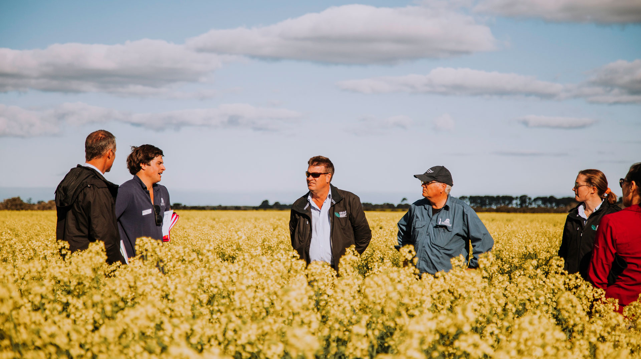

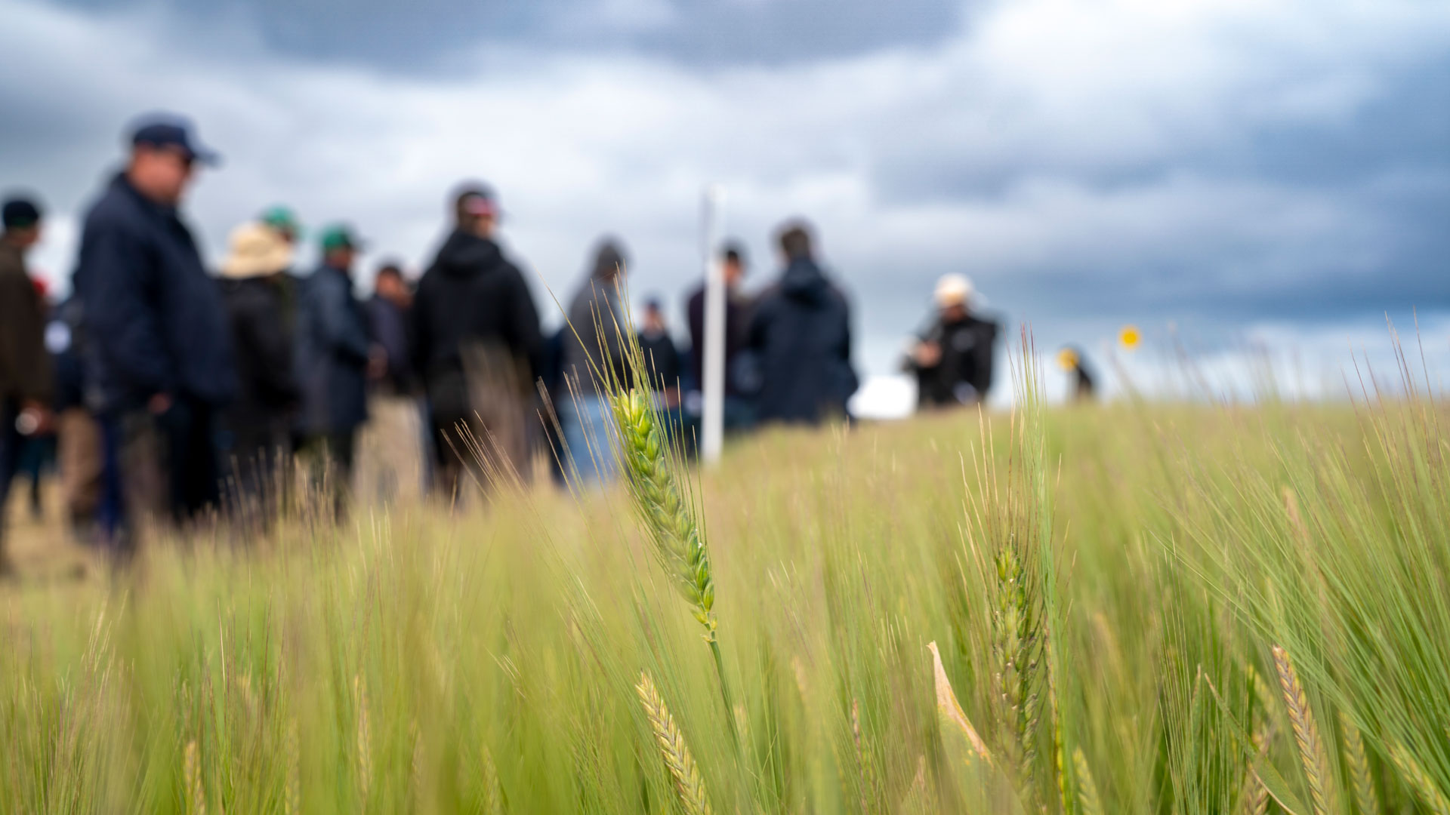

**REGIONAL PANELS**

ENSURE GRDC’S INVESTMENTS ARE IN THE BEST INTERESTS OF GROWERS   
AND DELIVER IMPACT TO EACH GRAIN-GROWING REGION.

# CONTENTS

**REGIONAL PANEL MEMBER   
APPLICANT INFORMATION 4**

NORTHERN REGION 4

SOUTHERN REGION 5

WESTERN REGION 5

**THE ROLE OF REGIONAL PANELS 6**

**REGIONAL PANEL MEMBERS   
CALL FOR APPLICATIONS 7**

APPOINTMENT TERMS AND CONDITIONS 7

DECLARATION OF INTERESTS 7

APPLICATION PROCESS 8

**ATTACHMENT A – KEY TERMS OF PANEL   
MEMBER AGREEMENT 9**

The **Grains Research and Development Corporation (GRDC)** is a corporate Commonwealth entity established to plan and invest in research, development and extension (RD&E) on behalf of Australian grain growers.

GRDC’s purpose is to invest in Research Development and Extension (RD&E) to create enduring profitability for Australian grain growers.

GRDC has approximately 125 staff with offices in Canberra, Perth, Adelaide, Toowoomba, Wagga Wagga and Horsham. GRDC is overseen by an independent Board appointed by the Minister for Agriculture, Fisheries and Forestry. The Board appoints the Managing Director who in turn appoints the Executive team.

GRDC’s organisational structure is divided into four business groups led by a General Manager:

* Genetic Technologies, Biosecurity and Regulation
* Applied Research, Development and Extension
* Strategy and Business Development
* Operations

In addition to these business groups the Human Resources, Legal and Governance and the Communications Teams report directly to the Managing Director.

GRDC has established three Regional Panels, representing the principal cropping zones across Australia – Northern, Southern and Western regions. The Panels work with GRDC Management to help guide the research, development and extension activities in each region and nationally.

# **REGIONAL PANEL MEMBER** APPLICANT INFORMATION

## Northern Region

The Northern Region encompasses Queensland and New South Wales and has generally high inherent soil fertility, although there is increasing evidence that this has been run down over time.

The Northern Region is the most climatically diverse of the three regions. The climates in the main grain belt range from winter dominant temperate to summer-dominant subtropical.

The Region also has the highest diversity of production, including all 25 leviable crops, as well as the highest percentage of mixed farming systems (livestock, cotton and sugar).

An increased focus on crop rotation, farming system management, water use efficiency and stubble retention has resulted in more profitable and lower risk systems over time, though the region is still characterised by highly variable yields.

This Region has relatively high seasonal rainfall and production variability, and both summer and winter crops feature in the farming system. Yield depends, to a significant degree, on conservation of soil moisture.

The Northern Region is the largest source of Australia’s premium hard high-protein wheat for export and domestic use, though demand for feed grains from the Region’s important livestock industries is also a driver.

so

## Southern region

The Southern Region includes South Australia, Tasmania and Victoria and encompasses a range of soils and agroclimatic zones. Soil fertility varies from highly fertile soils through to water-repellent sands, with some areas affected by subsoil constraints. Rainfall is winter dominated and varies significantly by location.

Yield potential is highly dependent on winter and spring rainfall. The conservation of soil moisture from summer and autumn rainfall events is a focus.

Major crops include wheat, barley, grain legumes and canola. Crop production systems and rotations are highly varied and include intensive continuous cropping systems and mixed farming enterprises (livestock and hay).

The Southern Region has a diverse suite of soils, including of lower fertility and with many subsoil constraints, such as salinity, sodicity and toxic levels of some elements. There are also some areas with very productive soils. Yield potential depends on seasonal rainfall, especially in autumn and spring, and there is lessened dependence on stored soil moisture than in the Northern Region. Crop production systems are varied and include many mixed farming enterprises with significant livestock and cropping activities.

## Western Region

GRDC’s Western Region comprises the cropping areas of Western Australia, where soil fertility is generally low, and yields depend on winter and spring rainfall.

Long-term variability in seasonal rainfall and production in coastal areas is lower than in the Northern and Southern Regions.

In many areas, yields are low by world standards; this is compensated for by the large scale and level of mechanisation within these enterprises.

Wheat, barley, oats, canola and lupins are the dominant crops, and livestock enterprises in mixed farming systems are generally less important than in the other Regions.

The Western Region exports more than 85 per cent of its grain production.

Panel members’ combined skills, knowledge and experience provide GRDC with a valuable network to help identify, understand and evaluate local, regional and national grains industry constraints and opportunities to enhance grain grower profitability. The GRDC Board considers the appointment of members to the Regional Panels as crucial to GRDC’s success.

Each regional panel:

* identifies and monitors regional and national grains industry constraints and opportunities to enhance grain grower profitability that are relevant to the Region
* interacts with GRDC’s National Grower Network, farming systems groups, and other interested parties in the region to identify RD&E ideas and investment options
* helps inform GRDC’s strategic investment areas
* reviews investment proposals presented by GRDC staff, provides feedback to GRDC investment managers and investment advice to National Panel
* in partnership with GRDC staff, keeps growers and advisers in the region informed and aware of GRDC’s strategic investment direction, its investment portfolio and specific research projects
* assists staff in monitoring the effectiveness of the investment portfolio.

# **THE ROLE** OF REGIONAL PANELS

The Regional Panels are composed of grain growers, advisers, agribusiness representatives, researchers and a GRDC General Manager, with provision for other industry experts to participate as appropriate. Regional Panel members are engaged under an agreement (akin to a consultancy agreement) to carry out their roles. Regional Panel members are advisors to GRDC and are not employees. The Senior Regional Manager and Panel Support person in each Region provides support to and facilitates the effective operation of the Regional Panel.

Further Information on current Regional Panel members is available from GRDC’s website at <https://grdc.com.au/about/who-we-are/our-structure/panels>.

## Appointment terms and conditions

Regional Panel Members will be appointed initially for a period of two years **on and from 1 September 2023** and engaged by GRDC pursuant to a Panel Member Agreement. Key terms of the Panel Member Agreement are included at **Attachment A**.

Successful candidates would be required to commit to and have the capacity to be able to meet the **minimum time requirement of 20 days per annum**. Panel members may be requested to contribute up to 10-20 additional days if they are willing and able to do so. Candidates should clearly indicate the minimum time that they are able to commit to the role if they are successful.

Sitting fees for the role of Regional Panel Members is currently **$828 per day**. This figure is based on a benchmark set by the Remuneration Tribunal.

## Declaration of Interests

GRDC employees, Directors and Regional Panel members must seek to avoid conflict between their obligations to GRDC and other individuals or organisations. Successful Applicants will be required to provide a declaration of interests form and manage any conflicts in accordance with GRDC’s Conflict of Interest Policy.

# **REGIONAL PANEL MEMBERS** CALL FOR APPLICATIONS

The GRDC Board is seeking applications from individual grain growers, researchers, farm advisers and consultants for appointment to each of its Northern, Southern and Western Regional Panels. It is a requirement that a Regional Panel Member **resides or works** in the particular Region.

Applications are invited from candidates with the following skills, knowledge and experience:

* Extensive knowledge of the Australian and/or international grains industries, particularly in the areas of production, processing, trade, marketing and research
* Excellent communication skills including the ability to communicate with growers, scientists and GRDC investment managers both on an individual level as well as in a group situation
* Demonstrated ability to network (please include details of the geographic coverage of existing networks)
* Well-developed conceptual and strategic thinking skills
* Demonstrated understanding of the finance and investment management practices, tools and performance indicators used in modern agricultural businesses
* Demonstrated ability to work constructively in a team
* Demonstrated interest and involvement in research, development or extension in the grains industry and an awareness of strategically important issues that are current for the grains industry.

## the application process

Applicants are encouraged to apply through SEEK [[add link]]. Only complete applications will be considered.  Late applications will not be accepted.

**Applications must include**:

* a curriculum vitae (which should not exceed four (4) pages) which details relevant qualifications along with current and previous positions and professional activities;
* the details of **two professional referees** that GRDC is authorised to contact to seek further information relevant to the application for a role as a GRDC Regional Panel Member; and
* a cover letter which addresses the **Selection Criteria** and identifies the Regional Panel that the Applicant is applying for (Northern, Southern or Western) along with **evidence of the Applicant’s residence or place of work** within that Region, and the name of the Applicant’s current employer (if consent is needed for the Applicant to commit time to the Panel).

**Selection Criteria** (*please note that GRDC does not expect all Applicants to be highly competent in all areas of the Selection Criteria*):

1. Extensive knowledge of the Australian and/or international grains industries, particularly in the areas of production, research, development and extension.
2. Excellent communication skills including the ability to communicate with growers and scientists both on an individual level as well as in a group situation.
3. Demonstrated ability to network (please include details of the geographic coverage of existing networks).
4. Critical thinking skills with a proven ability to analyse and interrogate information.
5. Demonstrated understanding of the finance and investment management practices, tools and performance indicators used in modern business practice.
6. Demonstrated ability to work constructively in a team.
7. Demonstrated interest and involvement in research, development or extension in the grains industry and an awareness of strategically important issues that are current for the grains industries.
8. Please explain why you have chosen to apply for a role as a ‘GRDC Regional Panel Member’.

**Only complete applications which address the Selection Criteria and provide the information requested will be considered.**

Applications close at **5pm Australian Eastern Standard Time (AEST)** on **Thursday 13 April 2023**.

Applicants should be prepared to attend an interview with the Panel Selection Committee. These interviews will be held **in the period 12 to 23 June 2023** and may be face-to-face or via videoconference (to be determined with the shortlisted Applicant). Any travel costs relating to the interview process will be paid for by GRDC. It is anticipated that successful, appointed Applicants will receive an induction from GRDC in August 2023.

Applicants will be advised of the outcome of their application. Further information on Regional Panel recruitment can be found on GRDC’s website at [GRDC Careers](https://grdc.com.au/about/careers) or by emailing [RP2023@grdc.com.au](mailto:RP2023@grdc.com.au)

**Please note: Late applications will not be accepted**

**ATTACHMENT A**

**Key Terms – Panel Member Agreement**

**GRDC PANEL ROLES AND RESPONSIBILITIES**

* 1. Introduction
     1. GRDC's purpose is to invest in research, development and extension (**RD&E**) to create enduring profitability for Australian grain growers. To deliver on this purpose GRDC must have strong engagement with Australian grain growers to assist GRDC in ensuring the research, development and extension portfolio is aligned with the needs of growers. The Regional Panels are critical to GRDC delivering on purpose.
     2. GRDC recognises variations in local conditions throughout all grain-growing regions of Australia and therefore has established three Regional Panels to cover the northern, southern and western grains regions. Regional Panel members' combined skills and experience in growing, researching, processing grain and farm business management provides GRDC with a valuable network to draw out local, regional and national grains industry issues.
     3. Regional Panel members are appointed by the GRDC Board to represent their region and to advise GRDC on the identification and prioritisation of RD&E investments that best meet GRDC's purpose. GRDC considers the appointment of members to the Regional Panels as crucial to GRDC's success.
  2. Regional Panel Function
     1. GRDC Regional Panels undertake the following functions in accordance with the Investment Management Framework and Annual Cycle as in force from time to time:
        1. Contribute to the development of GRDC's RD&E strategies and advise on the alignment of GRDC's investment portfolio with those strategies.
        2. In collaboration with GRDC staff, contribute to idea capture and development of priorities.
        3. Work closely with Panel Chairs, other Regional Panel members, the Panel Secretariat and, where requested, GRDC staff.
        4. Provide advice to GRDC, through the Regional Panel to the National Panel, on investment priorities emanating from the regions.
        5. Advise GRDC, through the Regional Panel to the National Panel, on the portfolio balance of RD&E investments.
        6. Make recommendations, through the Regional Panel to the National Panel, on RD&E investment allocations in respective regions.
        7. In collaboration with GRDC staff, facilitate awareness of GRDC investments and research outcomes.
        8. Gather crucial feedback from industry and report to GRDC on local, regional and national grains industry issues relevant to GRDC.
        9. Gather feedback from industry and report to GRDC on RD&E priorities for each region.
     2. The core functions of the Regional Panels are mostly delivered through Regional Panel meetings and Portfolio Team meetings.
     3. A regionally based Panel Secretariat supports the activities of each Regional Panel, but is not a member of the Regional Panel. The Secretariat has responsibility for coordinating panel activities, taking minutes, collating priorities and providing information to the Regional Panel.
  3. Level of Activity
     1. The maximum annual number of days spent on GRDC business for which daily fees can be claimed is 30, unless otherwise approved by GRDC.
     2. Should a Panel Chair consider that a member of a Regional Panel requires payment for additional days in a financial year, the Chair will discuss the matter with the GRDC Delegate to seek approval.
     3. Activities associated with membership of a Regional Panel include attending meeting days, attending conferences / workshops, reviewing and evaluating investments, and meeting preparation.
     4. Panel Members will be paid a sitting fee. The Panel Member Agreement will also provide for a level of travel allowance and reimbursement of expenses incurred by the Panel Member in complying with the Panel Member Agreement (e.g. accommodation, meals, incidentals and taxi fares) provided the Panel Member has receipts or other material substantiating the expenses.
  4. Regional Panel Membership

The three Regional Panels consist of up to eleven members including growers, researchers, other industry participants, a Panel Chair and a GRDC General Manager.

* 1. Role of a Panel Chair

The Panel Chair plays a crucial leadership role in ensuring that the Regional Panel operates effectively. In addition to the Panel member responsibilities, Regional Panel Chairs are expected to:

* + 1. Chair Regional Panel meetings.
    2. Represent their region as a member of the National Panel.
    3. Facilitate communication between the National Panel and their Regional Panel.
    4. Manage Regional Panel activity, including:
       1. forward planning for how the Regional Panel will meet its objectives; and
       2. management of Regional Panel members' available days.
    5. Provide feedback to Regional Panel members on their delivery in contributing to the Regional Panel's objectives.
    6. Work closely and meet with the GRDC Delegate to achieve GRDC objectives.
    7. Provide a presentation to the GRDC Board, at least once a year, on:
       1. activities the Regional Panel has undertaken in their region to meet its objectives.
       2. issues arising in their region that are relevant to delivery on GRDC purpose.
  1. Role of a Regional Panel Deputy Chair

The Regional Panel Deputy Chair's primary role is to assist the Panel Chair. In addition to the Regional Panel member responsibilities, the Panel Deputy Chairs are expected to:

* + 1. Chair Panel meetings in the absence of the Panel Chair.
    2. Attend National Panel meetings at the discretion of the GRDC Delegate if the Panel Chair is unavailable.
  1. Confidentiality

Regional Panel members will strictly maintain the confidentiality of matters discussed at Regional Panel and other GRDC meetings and of information acquired by virtue of their position as a Regional Panel member.

* 1. Public Statements

Panel Chairs and Regional Panel members are not to represent or speak on behalf of GRDC. However, Regional Panel members and Panel Chairs may, with the prior written approval of the GRDC Contact that the relevant information may be made public, speak about and raise public awareness of GRDC's investments and research outcomes.

* 1. Use of Information
     1. Regional Panel members must treat as confidential and take all reasonable steps to preserve the confidentiality of all confidential information.
     2. Regional Panel members must only use the information obtained by virtue of their position as a Regional Panel member for the purpose of undertaking their role as a Regional Panel member.
  2. Relevant Procedures

Panel Members are subject to GRDC Policies and Procedures in force from time to time when undertaking Services including but not limited to:

* + 1. Code of Conduct.
    2. WHS Framework, Policy and Procedures (Fatigue Management Policy, Safe Travel Guidelines, Alcohol and Drug Policy).
    3. Conflict of Interest Policy and Procedure.
    4. Receiving Gifts and Benefits Policy.
    5. Complaints Handling Policy and Procedures.
    6. Public Interest Disclosure Procedures.

GRDC

PO Box 5367

KINGSTON ACT 2604

(02) 6166 4500

[**grdc.com.au**](https://grdc.com.au/)

